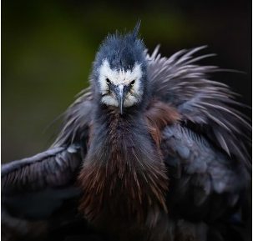
Liberty Leading the People
Inkjet Print on Canson Cotton Rag
65cm x 65cm
$775
Limited Edition 1/5

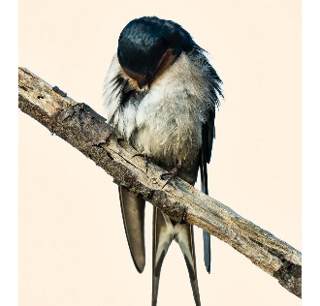
I’m Famous for Fifteen Minutes
(Peach)
Inkjet Print on Canson Cotton Rag
34.5cm x 52cm
$450
Limited Edition 1/5

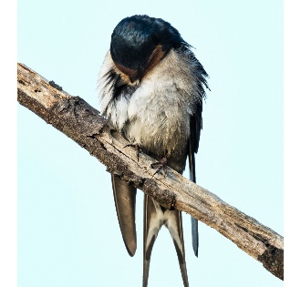
I’m Famous for Fifteen Minutes (Turquoise)
Inkjet Print on Canson Cotton Rag
34.5cm x 52cm
$450
Limited Edition 1/5
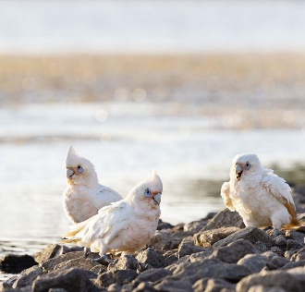
On the Waterfront
Inkjet Print on Canson Cotton Rag
35cm x 45cm
$400
Limited Edition 1/5

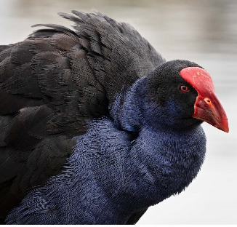
I Want my Baby Back
Inkjet Print on Canson Cotton Rag
35cm x 45cm
$400
Limited Edition 1/5

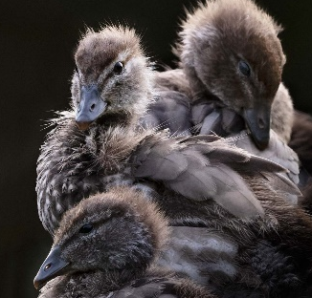
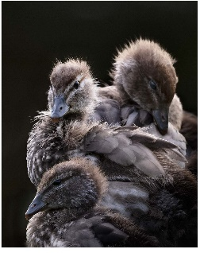
Nevermore
Inkjet Print on Canson Cotton Rag
35cm x 45cm
$425
Limited Edition 1/5
Carnival
Inkjet Print on Canson Cotton Rag
35cm x 45cm
$400
Limited Edition 1/5

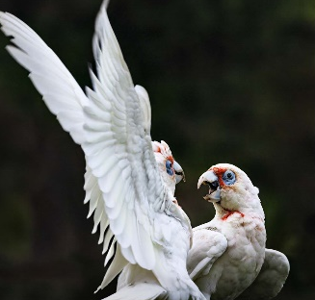
Rapture
Inkjet Print on Canson Cotton Rag
45cm x 45cm
$450
Limited Edition 1/5

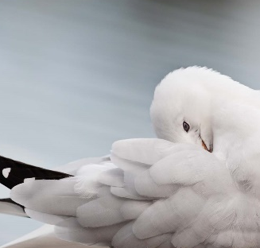
The Order of Things
Inkjet Print on Canson Cotton Rag
51cm x 32.2cm
$450
Limited Edition 1/5

As the World Falls Down
Inkjet Print on Canson Cotton Rag
41.5cm x 65cm
$700
Limited Edition 1/5

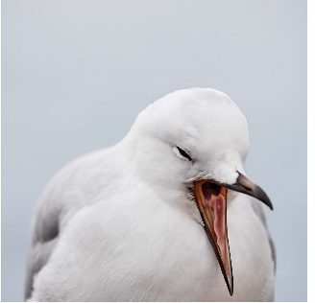
10,000 People Maybe More
Inkjet Print on Canson Cotton Rag
45cm x 45cm
$450
Limited Edition 1/5

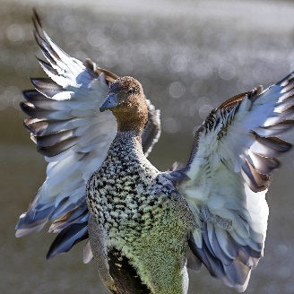
I’ve been Waiting for You
Inkjet Print on Canson Cotton Rag
45cm x 45cm
$450
Limited Edition 1/5

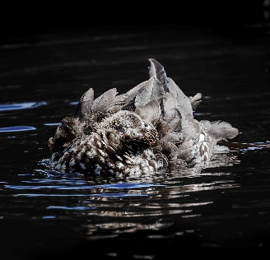
Midsummer Night’s Dream
Inkjet Print on Canson Cotton Rag
51cm x 32.2cm
$450
Limited Edition 1/5
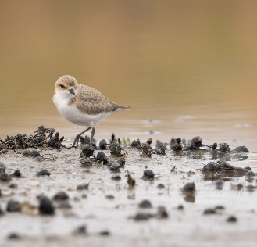
Last Night as I lay Sleeping
Inkjet Print on Canson Cotton Rag
51cm x 32.2cm
$450
Limited Edition 1/5

