Access Guide for Gasworks Arts Park

This access guide uses 14 pt in Arial font and uses 1.5 spacing. There are *no italics* but there is **Bold**. This Access Guide has 20 pages and contains photographs and a diagram of the venue.

Acknowledgment of Country

Gasworks Arts Park acknowledges First Nations’ sovereignty and recognises the continuing connection to lands, waters and communities by Traditional Owners of Country throughout Australia. We pay our respects to Aboriginal and Torres Strait Islander cultures; and to Elders past and present. We support and contribute to the process of Reconciliation.

Always was, always will be, Aboriginal land.

Gasworks is located 21 Graham Street, Albert Park on the stolen lands of the Boonwurrung and Woiwurrung people of the Kulin Nation. You can read about the history of Gasworks on our website

https://gasworks.org.au/

# Contents:

* Getting to the venue
  + Public Transport
  + Bike
  + Parking
  + Accessible Parking
  + Images of Accessible Parking
* Theatre Works Box Office Hours + Black box cafe + Bar
  + Office Hours
  + Cafe
  + Bar + Bar Menu
  + What to wear to the theatre
  + What to bring to the theatre
* Venue Information
  + Lighting
  + Sound
  + Toilets
* Access Services
  + Wheelchair Access
  + Companion Cards
  + Hearing Impairment Access
  + Diagram of the Gasworks layout
  + Seating
  + Railing
* Before, during and after Performance Information
* Support

**Getting to the venue** Gasworks Address

21 Graham Street

St Kilda VIC 3206

Australia

(corner of Graham and Pickles Streets, Melway ref: 57, D4)

# Public Transport

Gasworks is easily reached by public transport. Tram and bus services provide regular stops and pick-ups a short walk away from Gasworks.

Tram Services:

No. 1 tram from Swanston Street (to South Melbourne Beach). Disembark at Stop 31 (Tramtracker ID 1241) and walk down Graham Street. Alternatively, if you reach the beach, walk along the beach front towards the right (if you’re facing the ocean), then turn right up Pickles Street.

No. 109 tram from Collins St (to Port Melbourne). Disembark at Stop 128 and walk down Graham St. (This route has disabled access. Please call 1800 800 007 for more information).

Buses: 234 Garden City to City (Queen Victoria Market) / 236 Garden City to City (Queen Victoria Market) via South Melbourne

# Bike

There is a Melbourne Bike Share station located on Pickles Street, near the Graham Street entrance to Gasworks Arts Park.

# Parking Options

There is plenty of free, unrestricted street parking surrounding Gasworks Arts Park.

# Accessible Parking

There are three accessible parking spots at the Graham Street entrance of Gasworks. The image below is a photograph of where two of these parking lots are located. The second image is a screengrab of a map that shows where the three parks are located on the street from a birds eye view. The three purple circles mark Accessible Parking on the map. The Yellow star marks the audience entrance to the Gasworks foyer.

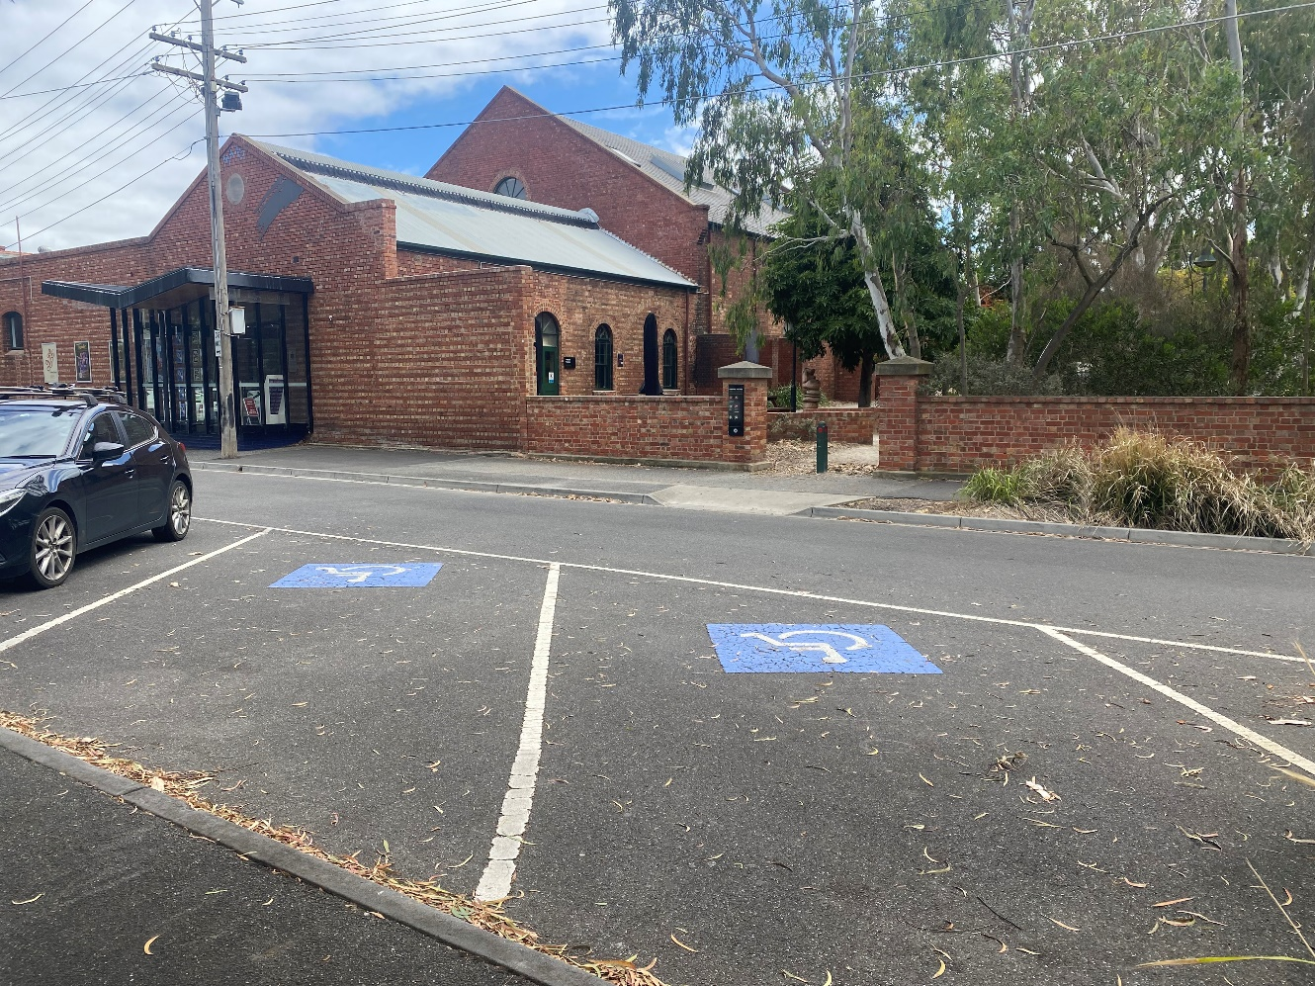

**Image Description**: A photograph of two accessible parking spaces opposite the Gasworks Theatre entrance.

# Map View

A screengrab of a map where the three accessible parks are located.

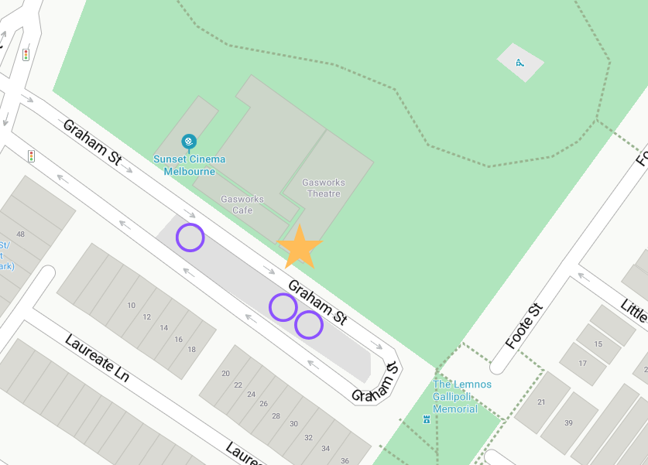

**Image Description:** This is a screengrab of a map that shows where the three accessible parks are located on the street from a birds eye view. The three purple circles mark Accessible Parking on the map. The Yellow star marks the audience entrance to the foyer.

# Gasworks Cafe

Our cozy café is the perfect spot for coffee lovers and dog enthusiasts alike. Signature coffee blends, delicious pastries and deserts, and freshly cooked meals.

Monday to Saturday, 7am-3pm Thursday to Sunday, 5pm-8pm

Sunday, 8am-3pm

You can order at the cafe through the open window or indoors at the counter. The cafe is cash free and dog friendly

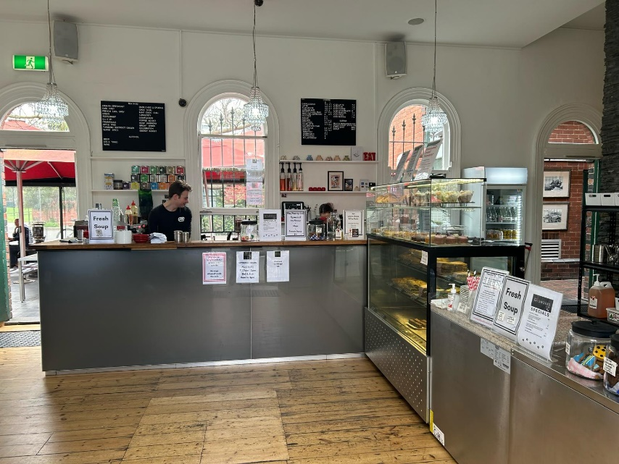You can sit inside the cafe or outside.

The image to the right is a photograph from inside the cafe. Our friendly staff are behind the counter next to the coffee machine. The cafe has oat milk, cows milk, soy milk and almond milk.

**Image Description:** A staff member who has short hair and a black T-shirt is facing the window behind the counter.

There is a view through the door to the left of outdoor seating, and the service window is seen directly behind the counter. The rest of the photograph is taken up by the wooden foyer floor and stainless-steel pastry shelf.

# Gasworks Box Office Hours

The Box Office opens approximately 45 minutes prior to the scheduled show start time.

If you have selected “print at home” tickets, you can either print your tickets, or have them on your mobile phone for us to scan when you enter the theatre. You can also pick up your tickets from the Box Office prior to the show. Double check your booking confirmation and it will say whether you’re picking up your ticket at the box office or printing it at home yourself. If there is allocated seating – your seat number will be printed on your ticket.

# Gasworks Foyer Bar

The Gasworks Foyer Bar opens approximately 45 minutes before the show, so you can meet your friends for a pre-show drink. We serve delicious Brown Brothers wine, assorted beers, cider, soft drinks and snacks.

Our bar is cash free which means we only accept card payments. There are EFTPOS facilities available at the bar and box office. You can tap, swipe or insert your card. Purchases must be at least 5 dollars.

There will be an employee behind the bar to serve you. Sometimes they might be getting extra stock from out the back and you will need to wait a few minutes.

There is often a queue for the bar and you will need to wait your turn. They will prepare your order for you.

You are welcome to bring your drink into the theatre.

# What do I wear to Gasworks?

Casual, comfortable clothes. There is no dress code and what makes you comfortable makes us comfortable. If it’s a cold night, we would recommend wearing warm clothes. The theatres and foyer are airconditioned.

# What do I bring?

Your ticket (digital is preferred). A mask if desired. Assistance and guide dogs are welcome at Gasworks.

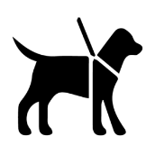

# Venue Information

Gasworks is situated on the site of the former South Melbourne Gas Plant. It is three kilometres from the CBD. The precinct houses four hectares of park, two theatres, three gallery spaces, a café, and function and workshop spaces. The theatres include the Gasworks Theatre and a smaller Studio Theatre.

# Main Venue Lighting

The foyer at Gasworks is lit by daylight from its windows and warm LED lights.

The bar at Gasworks is lit overhead with LED lights.

Both theatre entrances have lower lighting than the foyer and bar.

The bathrooms are lit with fluorescent lights.

The outside area is quite dark after sundown, with some neon and LED lights for ambience.

There are street lights surrounding Gasworks, however the surrounding park can become quite dark at night if crossing to Richardson Street.

# Sound

There will be music playing at a low level in the bar and foyer at Gasworks. The bathrooms and hallway do not have any music but you may hear the foyer music.

You will hear music from the café outside the venue near the Graham Street entrance.

# Toilets

There is one set of female bathrooms and Gasworks and one set of male bathrooms at Gasworks, both of which have an ambulant bathroom. There is one gender neutral accessible bathroom between these.

Toilets are located in the hallway past the foyer and bar close to both theatres.

**Access Services**

# Wheelchair access

# disability access symbol wheelchair black

All Gasworks venues are wheelchair accessible. There is accessible seating in the front row of both theatres. Discounted wheelchair accessible tickets are offered as part of all Gasworks Produced shows.

The texture of the path around the venue varies. You may be on gravel, bluestone, or grass.

# Companion Cards

Gasworks offers a second ticket at no cost to people who possess a Companion Card. If you need to book a ticket for you companion or carer, this can be done when purchasing a ticket through our website. You can alternatively call Front Desk on 8606 4200.

# Hearing Impairment Access

# 

The Gasworks Theatre is equipped with an Assistive Listening System. Ask our friendly staff at the Box Office for a Hearing Loop or Earpiece.

Some of our shows are Auslan-interpreted. If offered, this will be noted on the Gasworks website.

# Image of the Gasworks layout

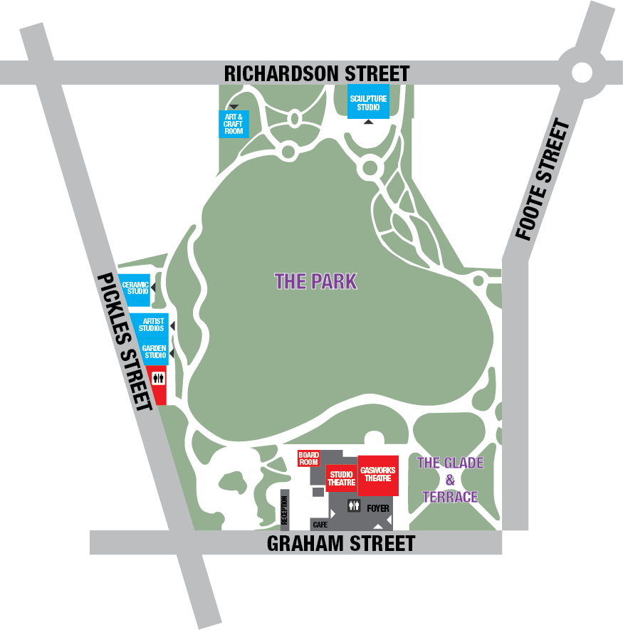This image shows the layout of Gasworks Arts Park.

**Image Description:** This is a to-scale map of the Gasworks layout. It is drawn.

**Image of Front Entrance**

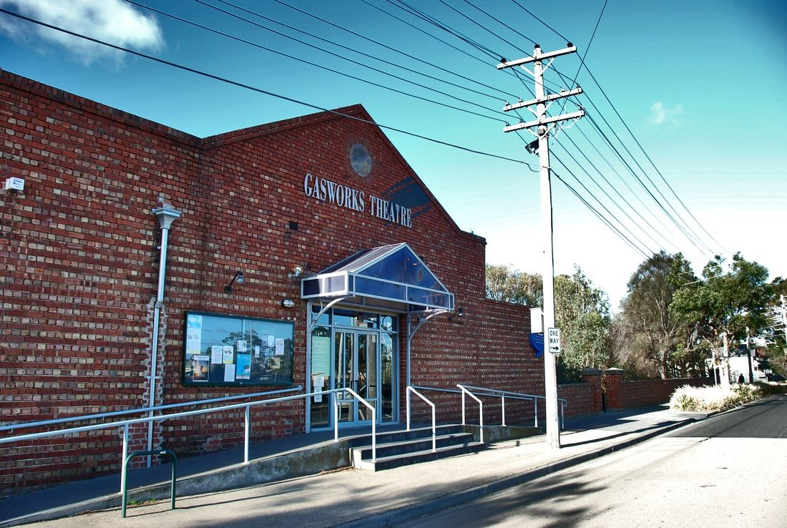

**Image Description:** A brick building with ramps and stairs out the front and signage saying Gasworks Theatre above the door.

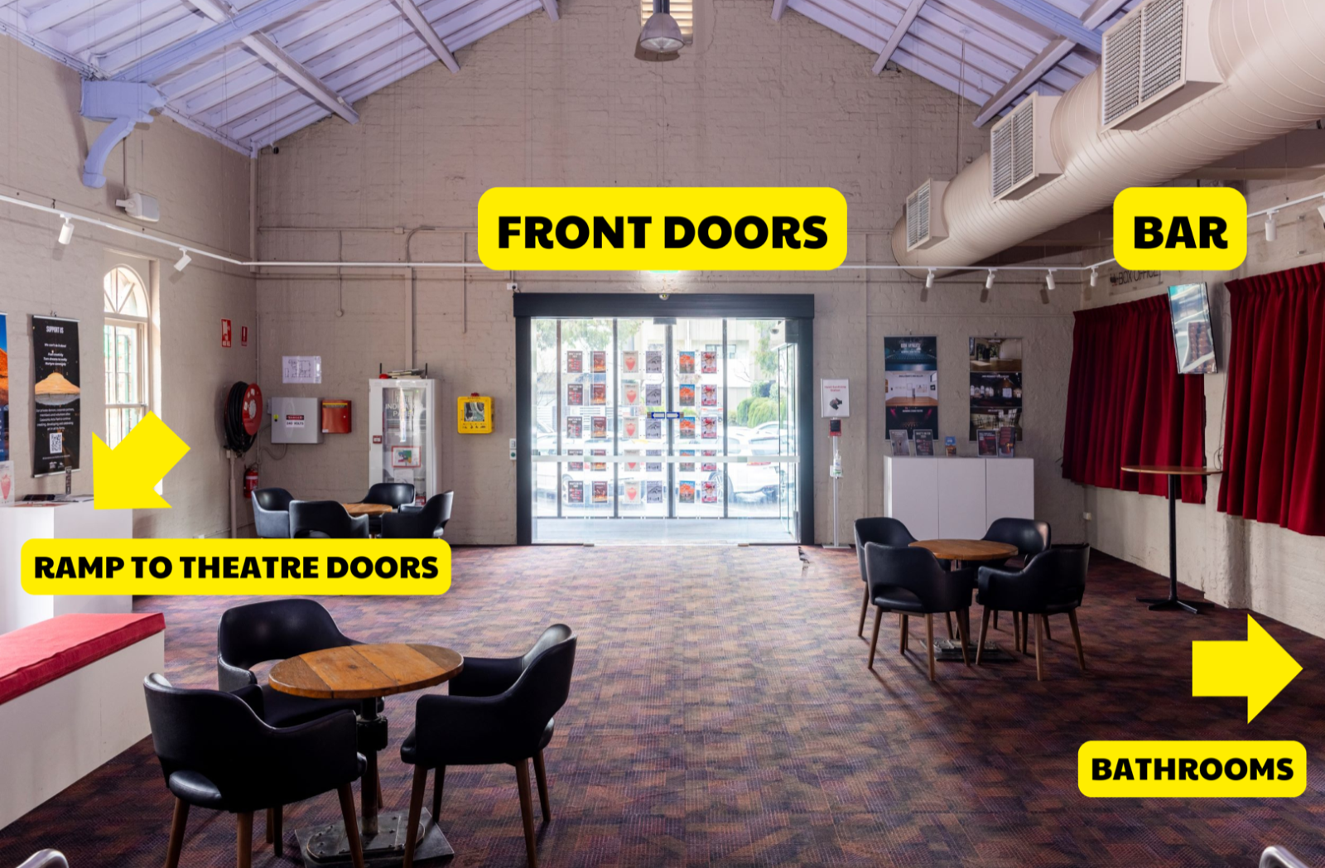

**Image Description:** An image of inside the foyer with the front doors and bar labelled and an arrows pointing to the ramp to the theatre doors and bathrooms.

## **Door to Performance Space**

There are large double doors leading to the performance space located at the end of the foyer, accessible via a ramp or two stairs.

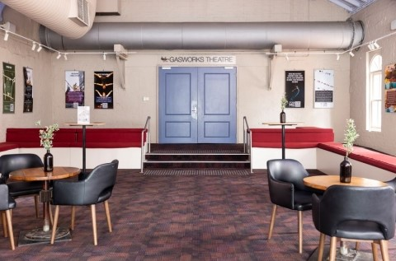

**Image Description:** An image of inside the foyer with blue double doors under a sign saying Gasworks Theatre. There are two steps in front of the door, and a ramp to the right of the door.

# Image of Studio Theatre Seating Bank

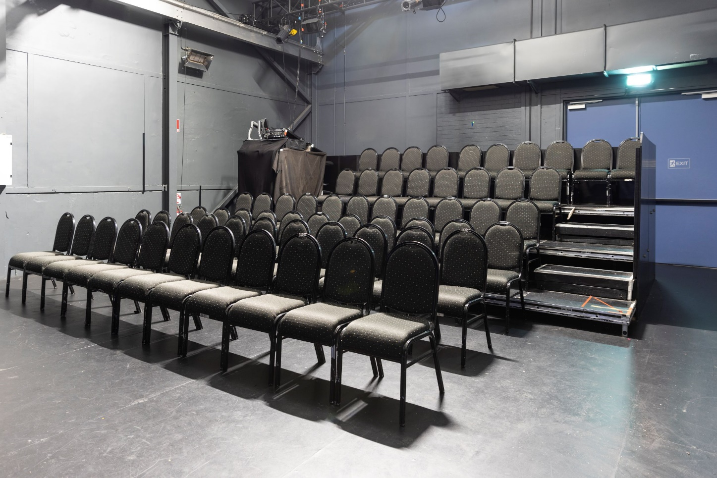

**Image Description:** This is a photograph of the 64 black seats in the Studio Theatre with the house lights on.

# Image of Gasworks Theatre Seating Bank

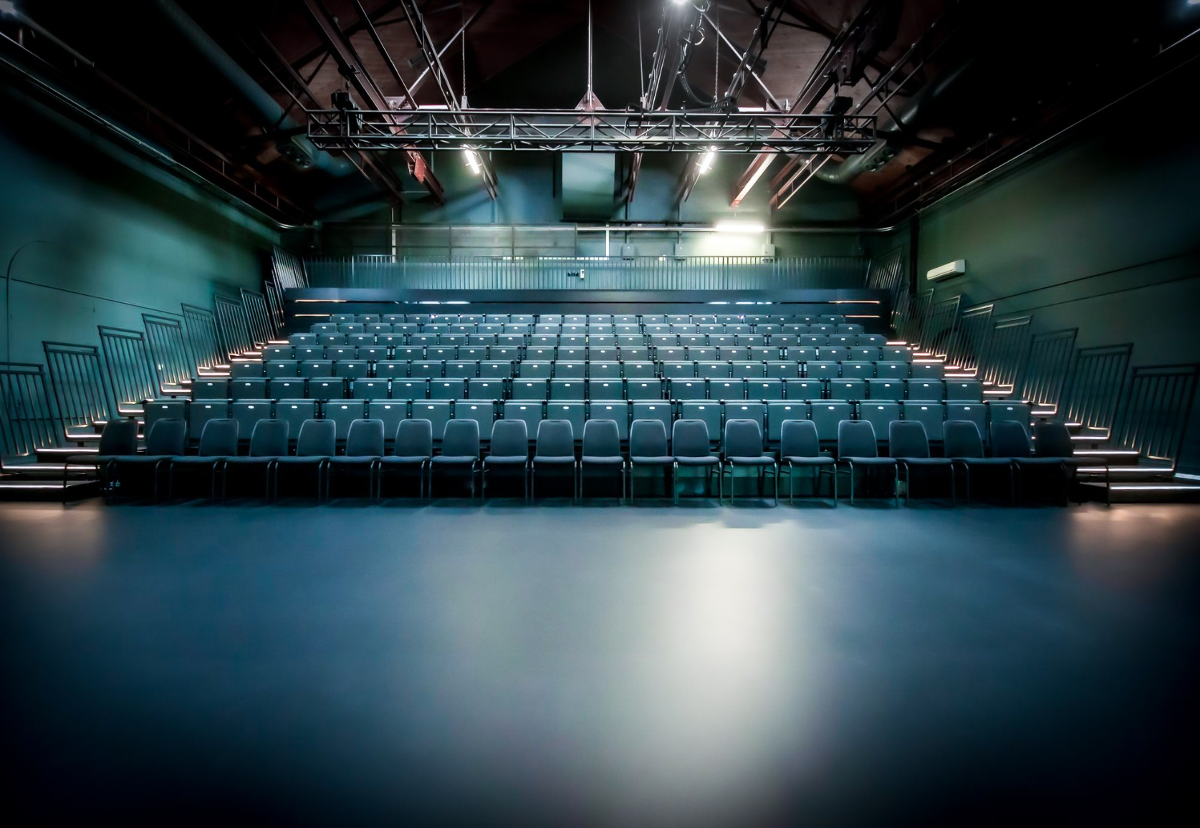

**Image Description:** This is a photograph of the 244 black seats in the Main Theatre with the house lights on.

# Studio Theatre Seating

There is general seating in the Studio Theatre at Gasworks. This means that there are no numbers allocated and that you can choose your own seat. The seats have black cushions on them with black metal surrounding the cushion. There are no armrests. There is room to put a bag under your seat. There is no room to put coats under the seats.

The front row of seating is wheelchair accessible.

Each seat has a clear view of the performance space without obstructions.

# Gasworks Theatre Seating

There is allocated seating in the Gasworks Theatre. This means that seats will be assigned to you upon purchase of a ticket. The seats are cushioned and black. The seats fold down easily. They sometimes make sounds when you move on them. There is railing on the side of both stairs. ‘

The stairs have rails that can be used for support. The rail sometimes makes a rattling sound when pressure is put on it but they are secure.

The front two rows of seating are unfixed and wheelchair accessible.

Each seat has a clear view of the performance space without obstructions.

If you have any specific seating requirements, you can let Gasworks Theatre know in advance by calling 8606 4200 or emailing: [frontdesk@gasworks.org.au](mailto:frontdesk@gasworks.org.au).

# Before, during and after Performance Information

**When do I enter the theatre?**

The Front of House staff will make an announcement five minutes before a show and open the doors to the theatre. You will scan your ticket at the Theatre entrance. You will then enter and find your seat. The house lights will be on. The audience will then turn off their phones or technological devices to not distract the performers.

# Before the Performance

When the audience is seated and the performers are ready, the house lights will go down slowly and the theatre doors will close. The audience will then be quiet. An ‘Acknowledgement of Country’ will be either spoken out loud or through a voice over. The show will then begin. If the show is not a relaxed performance, then you will be required to remain seated throughout the performance. Sometimes, shows will have a lockout policy (this means that if you exit during the show you cannot come back in). It is recommended to go to the bathroom before a show begins so you do not have to leave.

# During the Performance

When the show is on, the audience will react. If something is funny, they may laugh. If something is sad, they may cry. There is no right way to enjoy a show.

# After the Performance

When the performance is over, the lights will go down. The house lights will come back up. The performers will often bow. The audience will applaud. If someone really loves the show, they may stand up and clap for the actors. Then, the audience will vacate the theatre space. They may choose to hang around after the show to have a drink at the bar or talk about the show with other audience members. You are welcome to leave as soon as the show is finished.

# Support

**Support Act Wellbeing Helpline**

1800 959 500

24/7

[**Beyond Blue**](https://www.beyondblue.org.au/home)

24/7

1300 22 4636

# Headspace (12 - 25 year olds)

10am - 1am 1800 650 1800

**Parentline** 8am - 12am 13 22 89

# Safe Steps (Family Violence Response Centre)

24/7

1800 015 188

# Sexual Assault Crisis Line

5pm - 9am 1800 806 292

# Lifeline

24/7

13 11 14

# SANE

10am - 10pm 1800 187 263

# ARAFEM - Carer Helpline

9am - 5pm 1300 550 265