**Small Acts of Resistance**

By Women’s Circus

Access Guide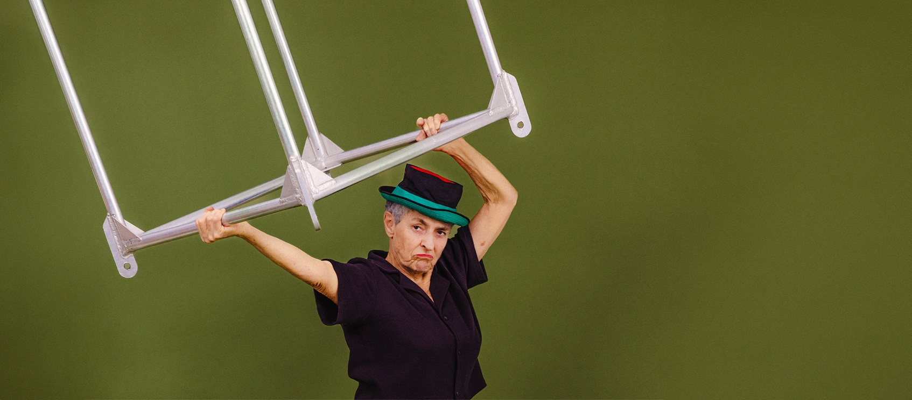**Photo: Alexis D-Lea**

**Image description:** Vig, one of the performers, holds a silver aerial cube above their head and wears a black shirt and black hat with green and red trim. They have a fierce expression on their face, and the background is olive green.

# **Updates to this document**

Please note, this performance is a new work, and changes are being made by artists until opening. We will endeavour to provide the latest access information on performances to ticket holders across key stages of rehearsal and presentation.

The Women’s Circus website will contain the most up to date version of this document and all ticket holders will be notified of major revisions prior to the event.

This document was updated: **Friday 31st of January 2025**

**Contents**

**Updates to this document** 1

**Where** 3

**When** 3

**Access Services** 3

**Performers** 4

**Sensory Elements** 4

**Sound** 4

**Lighting** 5

**Physical** 5

**Smell** 5

**Visual** 5

**Entry to space** 5

**Shocks or surprises** 5

**Audience experience** 6

**Social expectations** 6

**Performance expectations** 6

**Other** 6

**Content Warnings:** 6

**General Notes** 6

**The Venue** 7

**Front Entrance** 8

**Bar** 8

**Bathrooms** 9

**Door to Performance Space** 9

**Transport** 11

**Train** 11

**Tram** 11

**Bus** 11

**Parking** 11

**COVID Safety** 11

# **Where**

Gasworks Arts Park

21 Graham Street  
Albert Park

VIC 3206

# **When**

Wednesday 5th February – 6pm

Thursday 6th February – 6pm  
Friday 7th February – 6pm  
Saturday 8th February – 6pm   
**Duration:** 60 Minutes

# **Access Services**

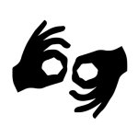

All performances are Auslan Interpreted. There is marked seating for the best view of the interpreter.

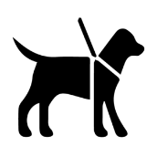

Assistance Animals are welcome.



Visual Rating 50% – this performance has music and sounds in the background.

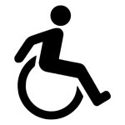

This performance is fully wheelchair accessible.

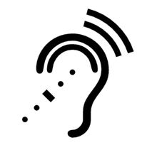

The Gasworks Theatre is equipped with an Assistive Listening System – simply pick up a Hearing Loop or Earpiece from the box office.

# **Performers**

Performers will be members of Women’s Circus social circus training program who are over 50 years old. There will mostly be duo and group acts.

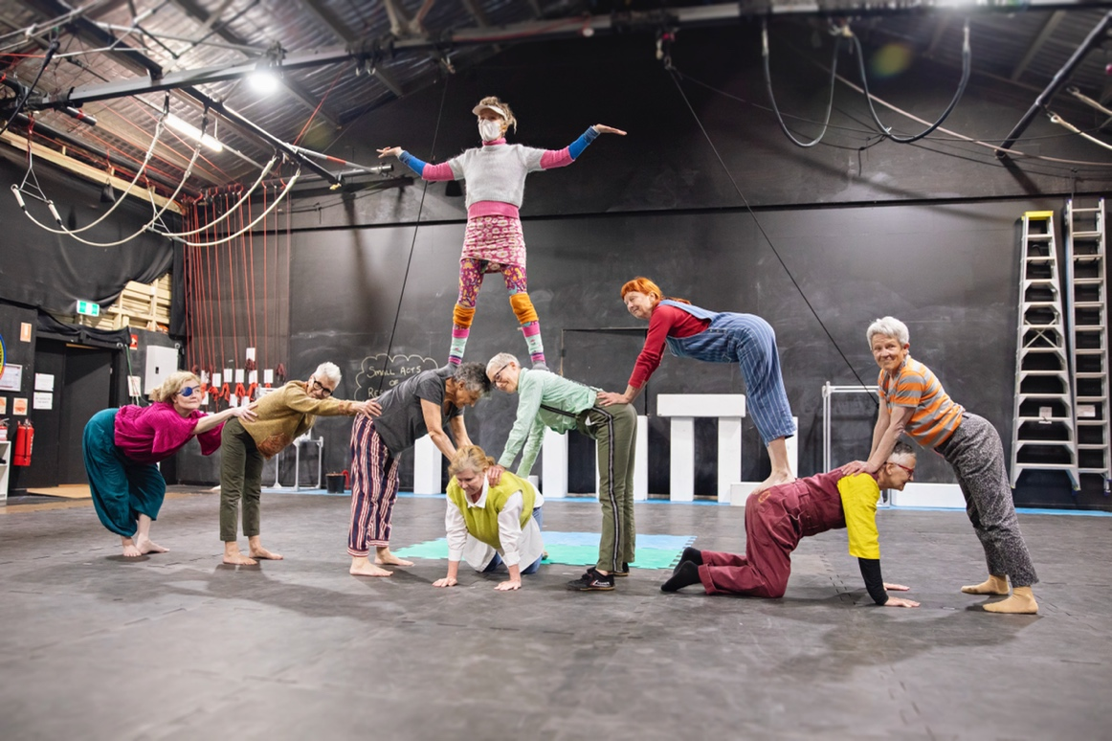

# **Sensory Elements**

## **Sound**

The sound is dynamic, with most of the sound being music; some loud music at times, and some soft music at times. There is recorded spoken word. There are also people talking into a microphone at times throughout the show. In addition, there are three clowning acts which are accompanied by a small brass band. The source of the sound is three large speakers hanging in the air facing the seating bank.

## **Lighting**

The lighting frequently changes in colour and intensity – there are both moving and static lights. Lighting states may change quickly during acts.

There are no strobing or fast-flashing lights. There are no lights directly pointing into the audience, but some seating positions will have some lighting spill on them due to the seating layout. Moving lights may also shine briefly into the audience as they move around.

## **Physical**

The stage space is soft puzzle mats and is plush seats in a raked seating. Performers may perform close to the edges of the stage where the front row of audience will sit and may also choose to interact with audience members that are sitting at the front of the space. Some of the performers are doing aerial acts where they will be up high, similarly there is also an act where performers are wearing stilts.

## **Smell**

There are no unusual smells involved in this work.

## **Visual**

The performance is colourful, and visually busy. It includes ground-based acts including acrobalance, stilts, physical comedy and clowning and aerial-based acts such as tissu, aerial cube and loops.

Audience Experience

## **Entry to space**

The theatre doors are located at the end of foyer, opposite the foyer entrance doors from the street. There is a ramp to the right, and an alternative pathway with two stairs in the centre. Your ticket will be checked by front of house staff.

## **Shocks or surprises**

There are no intentional shocks or surprises for the audience members.

## **Audience experience**

Performers may come close to the front row of audience members during their performances as the stage space is quite small, and there may be some audience interaction, particularly from the clowning and physical comedy acts.

If people do not wish to participate in any audience interaction, sitting in the middle of the space is advised.

## **Social expectations**

Audience is seated in a raked seating bank of 240 seats, and each seat has a clear view of the performance space without obstructions.

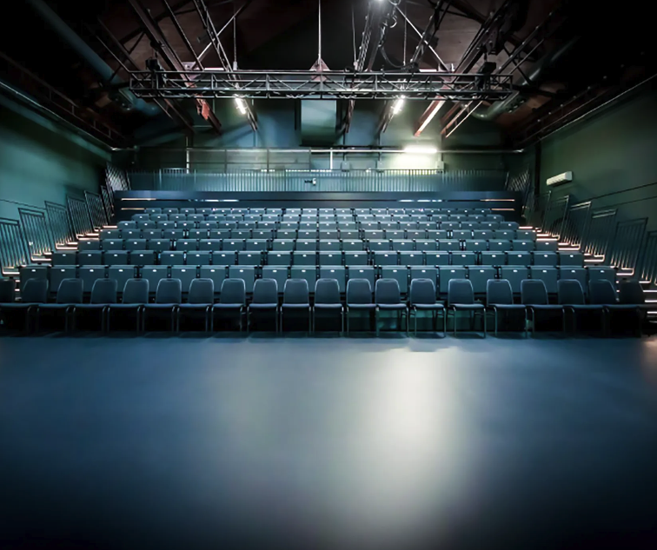

If you have any specific seating requirements, you can let Gasworks Theatre know in advance by calling [8606 4200](https://gasworks.org.au/visit-us/+61386064200) or emailing: [frontdesk@gasworks.org.au.](mailto:frontdesk@gasworks.org.au)

There will be pathways for easy access to and from the performance space, however there is no centre aisle in the seating bank.

## **Performance expectations**

Most of the performance is circus acts performed to music with no dialogue. There is some spoken word, and some live music played throughout the show using brass instruments. There will be large group acts using the whole cast and filling the stage, as well as duo acts and smaller group acts.  
  
The performers will be wearing costumes and some of them will be wearing makeup. They will be backstage or onstage and won’t be sitting in the audience. Some of them may be in the bar area after the performance if you would like to talk to them.

# **Other**

## **Content Warnings:**

There is use the use of strong language and mild sexual themes.

## **Running Order**

1. Group Acrobalance / Pyramids
2. Duo Aerial Tissu/Silks
3. Clowning Quiz Show
4. Body Percussion Group Act
5. Physical Theatre / Comedy Duo Act
6. Stilts
7. Movement Scene
8. Clowning Quiz Show
9. Duo Loops
10. Clowning Quiz Show
11. Aerial Cube – Group Act
12. Adagio (Duo Acrobalance)
13. Movement Scene - Group

**The Venue**

**Gasworks Arts Park – Main Theatre**

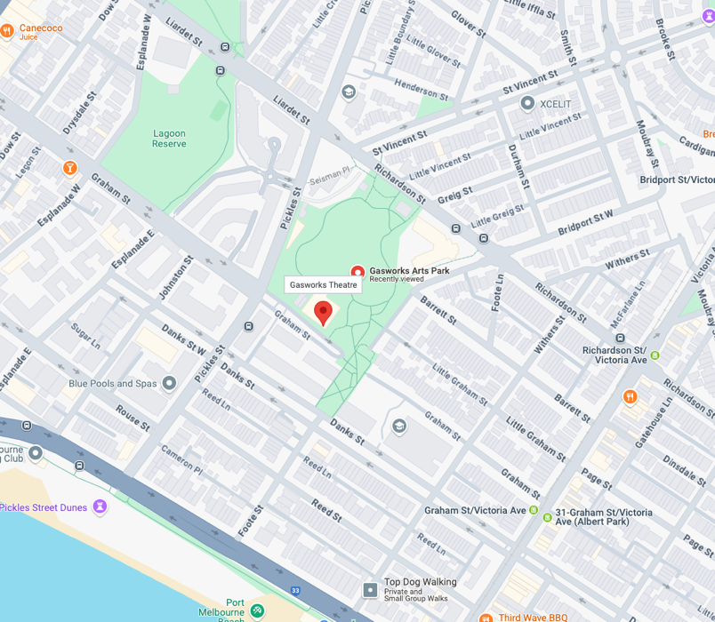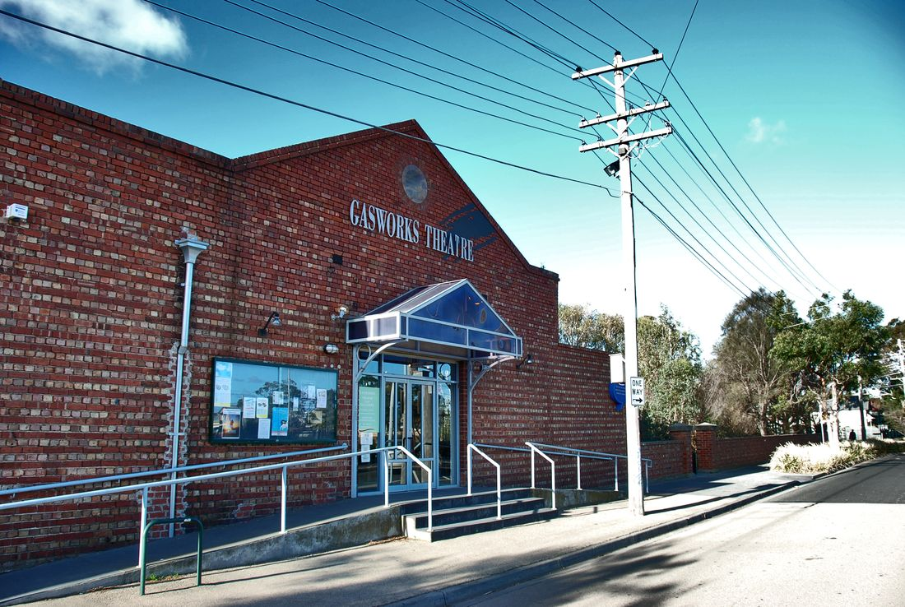

**Image 1:** A brick building with ramps and stairs out the front and signage saying Gasworks Theatre above the door. door and blue sign

**Image 2:** a map of Gasworks Theatre’s location and its surrounding area.

## **Front Entrance**

 

Image: A brick building with ramps and stairs out the front and signage saying Gasworks Theatre above the door.

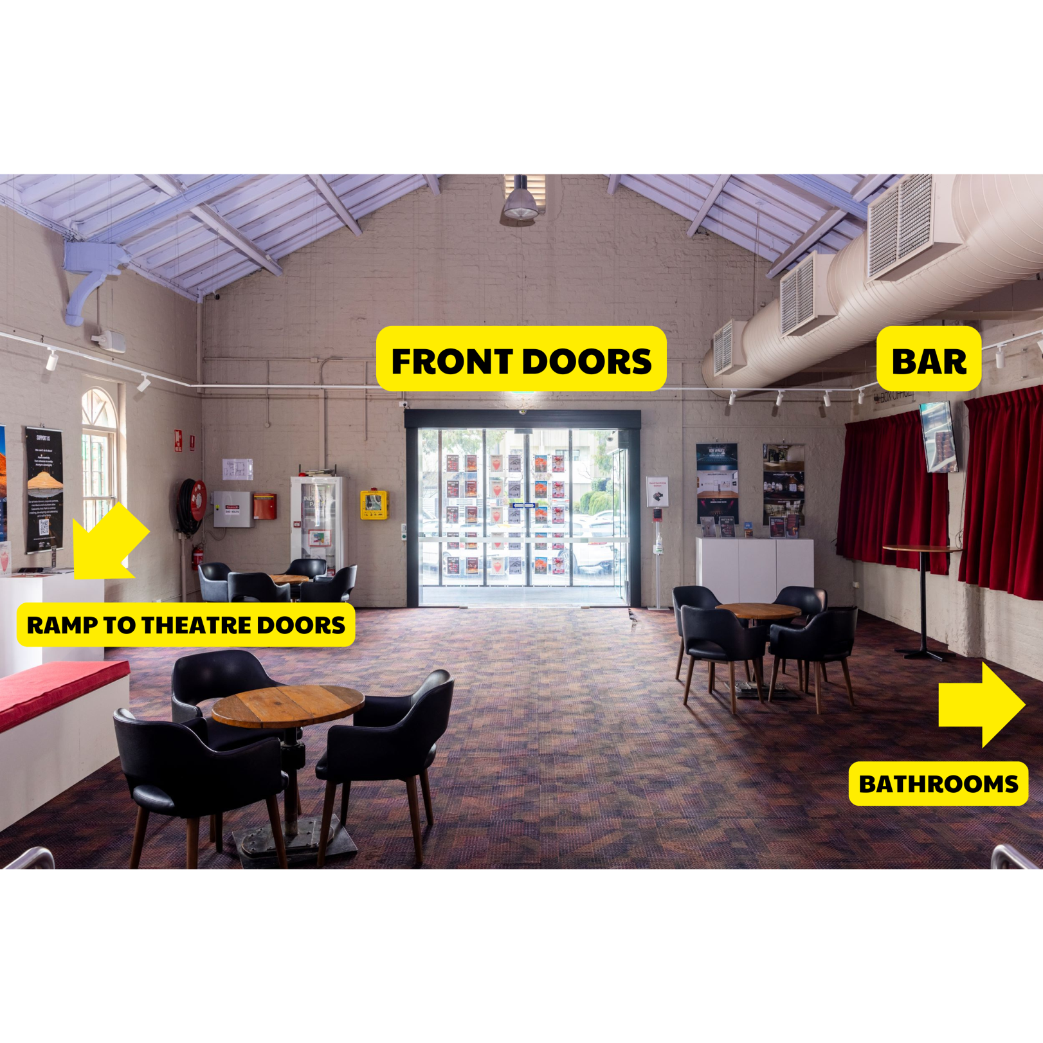

Image: picture of inside the foyer with the front doors and bar labelled and arrows pointing to the ramp to theatre doors and bathrooms.

## **Bar**

The Gasworks Foyer Bar open approximately 45 minutes before the show and is located after you enter the foyer on the left. They serve Brown Brothers wine, assorted beers, cider, soft drinks and snacks. There are EFTPOS facilities available at the bar and box office for purchases (minimum $5), but no cash out or ATM facilities.

## 

## **Bathrooms**

There are bathroom facilities down a hallway coming off the theatre foyer. The entrance to the hallway is located to the left after you enter the foyer after the bar. There is an accessible bathroom.

## 

## **Door to Performance Space**

There are large double doors leading to the performance space located at the end of the foyer, accessible via a ramp or two stairs.

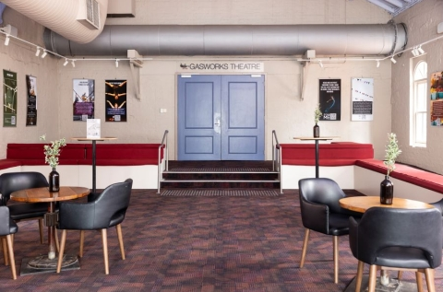

# **Transport**

## **Tram**

No. 1 tram from Swanston Street (to South Melbourne Beach).

Disembark at Stop 31 (Tramtracker ID 1241) and walk down Graham St.  
Alternatively, if you reach the beach, walk along the beach front towards the right (if you facing the ocean), then turn right up Pickles Street.  
No. 109 tram from Collins St (to Port Melbourne).

Disembark at Stop 128 and walk down Graham St. (This route has accessible. Please call 1800 800 007 for more information)

## **Bus**

Catch bus routes 234 or 236. For all public transport timetable and service information please see Metlink Journey Planner ptv.vic.gov.au or call 131 638.

## **Parking**

If you are driving to Gasworks Arts Park, the address is 21 Graham Street, Albert Park (corner of Graham and Pickles Streets, Melway ref: 57, D4).

There is plenty of free, unrestricted street parking surrounding the park.

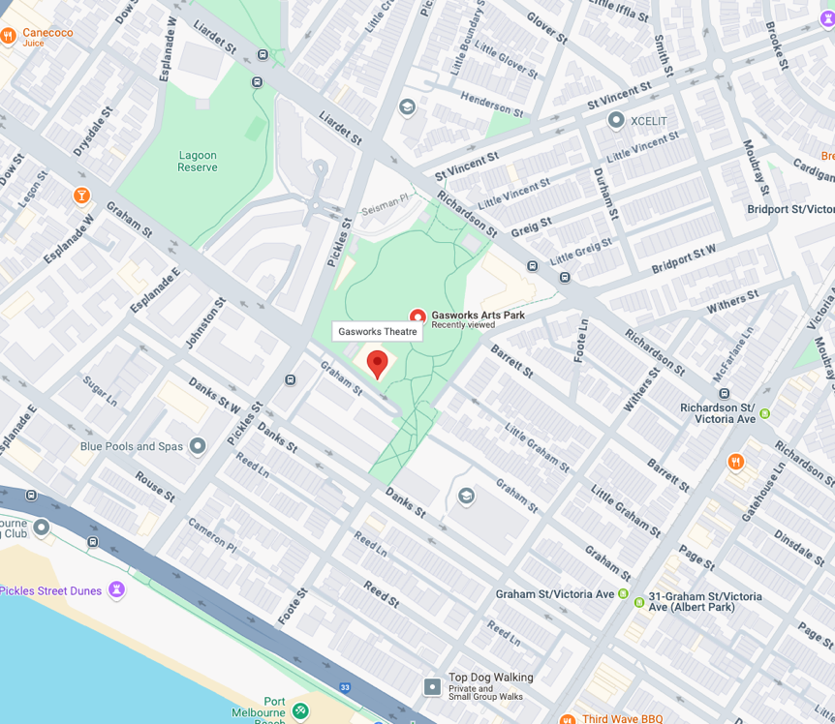

# **COVID Safety**

If you have a cough, sore throat, fever, shortness of breath or flu-like symptoms, please reconsider attending the performance.

To minimise the risk of COVID-19 transmission, we advise all patrons, artists and staff to:

* Practise physical distancing where possible
* Practise good hygiene by washing and or sanitising your hands often

Staying COVID-safe remains important. We must all follow these steps:

* Follow the [Victorian Government’s measures on how to stay safe.](https://www.betterhealth.vic.gov.au/coronavirus-covid-19-victoria)
* Practice [COVID-safe hygiene protocols.](https://www.health.gov.au/news/health-alerts/novel-coronavirus-2019-ncov-health-alert/how-to-protect-yourself-and-others-from-coronavirus-covid-19/good-hygiene-for-coronavirus-covid-19)